 Uber Technologies, Inc.

**Product Dissection for Uber**

**Company Overview:**

**Uber Technologies, Inc.** (commonly referred to as **Uber**) provides ride-hailing services, food delivery, and freight transport. It is headquartered in San Francisco and operates in approximately 70 countries and 10,500 cities worldwide. The company has over 131 million monthly active users and 6 million active drivers and couriers worldwide and facilitates an average of 25 million trips per day. It has facilitated 42 billion trips since its inception in 2010 and is the largest ridesharing company in the United States.

**Product Dissection and Real-World Problems Solved by Uber:**

What is Uber? We’ve noticed that it’s a popular question—is it a taxi service? Not quite. Public transport? Another good guess, but actually, Uber is an app that connects drivers with riders. It’s as simple as that.

Uber’s history started when Travis Kalanick and Garrett Camp found themselves stuck in Paris on a snowy evening, unable to find a taxi. They asked themselves: “What if you could request a ride simply by tapping your phone?” The thought of using a cell phone to order a ride from the exact location you were standing was revolutionary. People would no longer have to wait, hoping for a car to pass or walk the streets in search of one. This seemed to please many people, as Uber quickly became popular in big cities like San Francisco and Paris.

Below are ways in which Uber differ from the traditional cab system. Each is a problem with the traditional system that Uber solves.

1. Problem of Access to Reliable Taxi Services: Prior to Uber, getting a reliable taxi, especially in less populated or less frequent areas, was a challenging task. Uber's technology platform connects drivers with riders in real time, making it much easier for consumers to find a ride when they need one.

2. Overcoming Price Opacity in Taxi Services: Uber introduced upfront pricing based on the estimated distance and time making the pricing system much more transparent than traditional taxi meters.

3. Flexible Work Opportunities: Uber provides a flexible work opportunity for drivers. They can choose their work hours and manage work around their lifestyle, providing an employment solution for many who prefer this kind of flexibility.

4. Lowering Drunk Driving Incidents: In cities where Uber operates, studies have suggested a correlation between the availability of Uber rides and a decrease in drunk driving incidents, thus promoting safer roads.

**For the rider:**

1. Accountability - Uber ensures that the riders are being picked up and dropped to their requested destination. They also make sure that their driver won't abandon them on the middle of route.

2. Customer Service - Because of the rating system drivers and riders are conscious of their conduct. Both have incentive to behave and respect the other party as both rank each other after the ride is complete. Drivers must maintain a high rating (above 4.5) in order to continue being drivers.

3. Ease of pay - No cash necessary and therefore no need to worry about the always-broken credit card machine. They also have an option of paying through Uber credits where money from rider’s uber wallet gets deducted automatically as soon as the trip ends.

4. Supply - Because of price surging, which incentivized more drivers to sign on during busy times, passengers have a higher chance of finding a ride at all times.

5. Safety – Riders can share their trip details with loved ones. Track their trip during a ride. Uber’s technology helps put peace of mind at your fingertips. A specially trained team is available 24/7 where we can reach them in the app, day or night, with any questions or safety concerns.

**For the driver:**

1. Safety - Removing cash from the cab industry disincentivizes robbery and theft for drivers. The app is built with technology to help you stay connected to your loved ones and our support team, so you can go even further. Specially trained incident response teams are available anytime right from the app.

2. Choice - Due to the established rating system, drivers are able to obtain information regarding passenger behaviour through the shared experiences within the driving community prior to commencing a pick-up. This strategy effectively filters out passengers who have displayed unfavourable behaviour. It is analogous to the process of how poor-performing drivers are excluded. Additionally, Uber ensures that drivers are financially covered in scenarios where a passenger causes a disruption, such as resulting in a mess or physical damage to the vehicle.

3. Information - The Uber driver application gives real-time updates on the busiest (and surging) areas giving drivers a higher chance of finding riders. Uber also regularly emails and text drivers about main events happening throughout the city as well as road closures so that drivers increase efficiency and maximize earning potential.

**An Uber-Cool Business Model:**

Uber has a transparent business model. The Uber app leverages the company's massive network and technology to transport people and goods from one point to another. Uber does not have its own fleet of cars. Instead, its drivers use their own cars to provide cab services. The drivers pay Uber a 25% commission on the fare received from customers. The commission received by Uber is likely higher, as reports suggest Uber cuts hidden charges. Subsequently, on average, Uber rakes in up to 30% of the fare. At times of peak passenger demand, Uber adds a surcharge, so the ride at those times, can cost around 1.5X, 2X, 3X, or even more, depending on the extent of the demand.

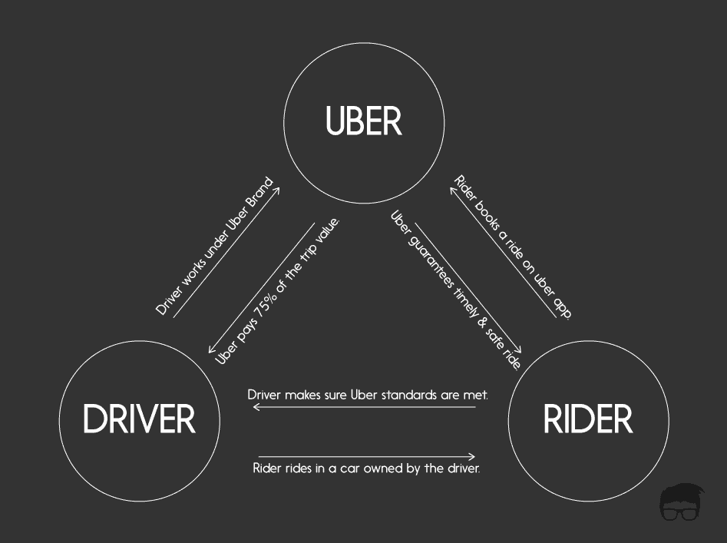

**Case Study: Real-World Problems and Uber's Innovative Solutions**

Successful products and services identify real problems and figure out how technology can be leveraged to solve them. Uber’s founders made sure they’re going to be able to get a ride during a cold winter night by using mobile technology to transform on-demand transportation. As evident from the value propositions, Uber has two main target segments - passengers who want a fuss-free experience ride from A to B and drivers that want flexibility and some extra income, usually on the side. When it comes to passengers, Uber’s website’s headline for a long time was: Everyone’s private driver. That instantly lets us know that Uber’s target market is very, very wide. It’s everyone who needs a ride. While targeting several customer segments with different cost-conscious and more luxurious service options, what’s perhaps more important is how Uber reached its audience at the very beginning as you can’t just target everyone from the get-go.

**Problem 1: Problem of Access to Reliable Taxi Services**

**Real-World Challenge:** People were facing problems of not getting a cab on time. People had to pay a lot and also need to wander around on the road to look for a cab and then hop in to travel. There were situations where driver charged more for the trip and many more.

**Uber’s Solution:** Uber came up with a solution where you could request a ride simply by tapping your phone sitting at your place. Provide drop and pickup location, select the type of vehicle and then book your ride. Also, here the rider would be displaced the price of the ride prior booking which created transparency and all these features created easy of travelling to the riders. Riders can share their trip details with loved ones. Track their trip during a ride. Uber’s technology helps put peace of mind at your fingertips. A specially trained team is available 24/7 where we can reach them in the app, day or night, with any questions or safety concerns. To Uber both the driver and the rider are their customer. Both have an option of rating each other after completion of the ride which helps Uber maintaining its company standards. Uber also provide wide varieties of vehicle option to choose for like in India we have option for bike, auto, Hatch back car, Sedan car, SUV and in foreign countries we also have an option for Luxury cars which comes under Uber Black and also a helicopter.

 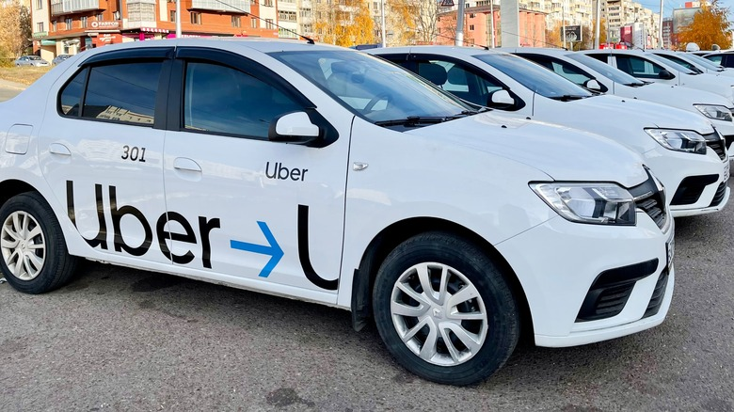

**Problem 2: Accessibility to Multiple Restaurants and Enhanced Reach and Promotion for Restaurants**

**Real-World Challenge:** People were limited to the restaurants that delivered in their nearby area. They had to go to the restaurant and pick up their parcels There were no discounts or offers available back then.

**Uber’s Solution:**

**1. Accessibility to Multiple Restaurants:** Before Uber Eats, customers were limited to the restaurants that delivered in their nearby area. Uber Eats has significantly expanded the food options available for delivery by including a diverse range of eateries– from street food stalls to high-end restaurants, thus ensuring customers can eat whatever they are craving at home, work, or elsewhere.

**2. Efficiency and Convenience:** By providing a platform where customers can order from a variety of restaurants at the click of a button, and have it delivered to their doorstep, Uber Eats has greatly simplified and expedited the food ordering process.

**3. Real-Time Tracking:** Uber Eats integrated real-time tracking into its service, allowing users to see exactly where their food is at any given moment. This addressed the problem of uncertainty over delivery times, which is common with many traditional delivery services.

**4. Flexible Earning Opportunities:** Just like Uber's ride-hailing service, Uber Eats offers flexible work opportunities for delivery partners. They have the freedom to choose the hours and locations where they want to work. This provides an additional income source and employment opportunities to many people.

**5. Lowered Expenses for Restaurants:** By utilising the Uber Eats platform, restaurants can significantly cut down on the cost of running an in-house delivery service, including salaries, vehicle costs, insurance, and other overhead expenses.

**6. Enhanced Reach and Promotion for Restaurants:** Smaller or newer restaurants can leverage Uber Eats for reaching out to a wider customer base and enhancing their brand visibility. The platform's promotional activities can provide these establishments with marketing benefits that might be otherwise out-of-reach due to costs or logistics. By addressing these issues, Uber Eats has transformed the food delivery industry, much like Uber transformed the taxi and ride-sharing industries.

 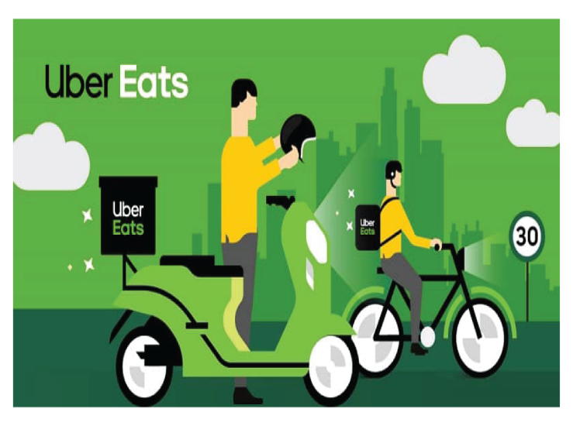

**Problem 3: Freight Services**

**Real-World Challenge:** Many individuals who were facing problems related to traditional freight operations. The problems were related to booking process which involved lots of paper work, fuel efficiency, payment related issues etc.

**Uber’s Solution:**

**1. Manual and Complex Booking Process:** Prior to Uber Freight, booking a freight load often involved numerous phone calls, emails, and paperwork. Uber Freight streamlined this process by creating a user-friendly app where carriers can book a load with just a few clicks.

**2. Pay Transparency and Speed:** The traditional freight industry often struggled with payment transparency and slow transactions. Uber Freight resolved this by providing upfront, transparent pricing and payments within a few days of job completion, thus improving cash flow for carriers.

**3. Load Matching Efficiency:** Before Uber Freight, shippers and carriers spent a lot of time matching loads. Uber Freight's platform connects shippers and drivers based on factors like location, equipment type, and cargo specifications, greatly improving load matching efficiency.

**4. Real-time Tracking:** Uber Freight allows shippers to track their freight in real-time, tackling the problem often faced with conventional freight shipping of not having real-time visibility of shipment status.

**5. Personalized Load Recommendations:** Uber Freight offers carriers personalized load recommendations based on their past behaviour, preferences, and other business needs, which optimizes load planning and scheduling.

**6. Reduced Empty Miles:** By efficiently matching freight with carriers based on various factors, the platform helps in reducing "empty miles" travelled by trucks, hence promoting fuel efficiency and reducing environmental impact. By digitizing and modernizing the logistics and freight industry, Uber Freight helped to eliminate many inefficiencies, making the process quicker, more reliable, and more transparent for shippers and carriers alike

 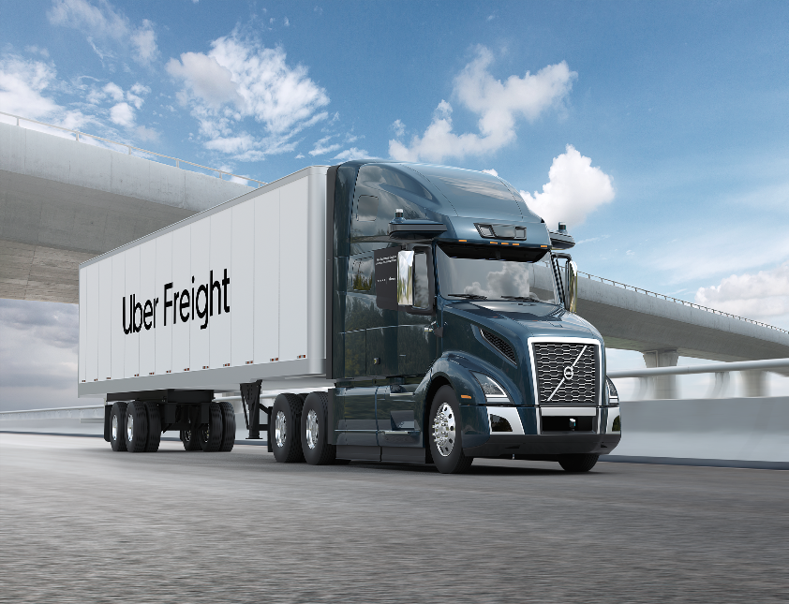

**Problem 4: To prevent Air pollution**

**Real-World Challenge: The lack of awareness among passengers about the environmental impact of their transportation choices is leading to increased vehicular traffic and, consequently, a rise in harmful greenhouse gas emissions.**

**Uber’s Solution:**

Uber also collaborated with Tesla to use their electric cars as their Uber green vehicles.

**1. Environmental Pollution:** One of the major issues with ridesharing services is the contribution to environmental pollution due to the emission of greenhouse gases. Uber launched Uber Green with the objective of offering rides in electric vehicles (EVs) or hybrid cars that produce fewer emissions.

**2. Promotion of Electric Vehicles:** The usage of electric vehicles can significantly reduce carbon emissions. However, the adoption rate of EVs has been slow due to various reasons, including range anxiety and lack of charging infrastructure. By incentivizing drivers to switch to electric or hybrid cars, Uber Green is helping accelerate the adoption of cleaner vehicles.

**3. Urban Traffic Congestion:** Riding sharing contributes to the number of cars on the road, which can increase traffic congestion in city centres. Uber Green includes initiatives to reduce the number of cars by supporting public transit connectivity and promoting pooling rides.

**4. Awareness on Carbon Footprint:** Many passengers are unaware of the environmental impact of their transport choices. Uber Green provides riders the option to choose a more sustainable ride, thus raising awareness about their carbon footprint. The challenges that Uber Green is attempting to address are significant. It is part of a broader move towards sustainability that companies worldwide are recognizing as essential for their long-term success and for the health of our planet.

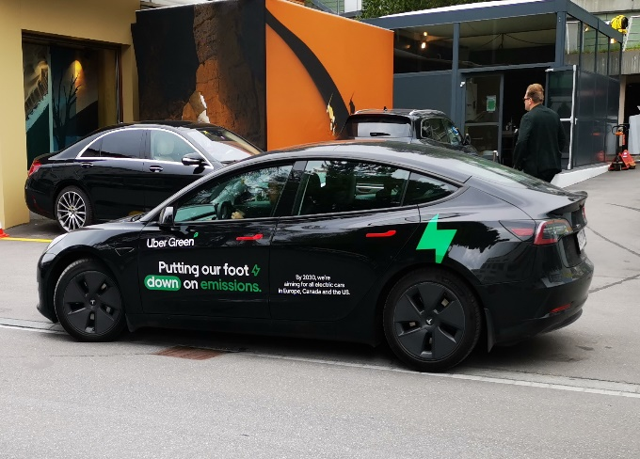 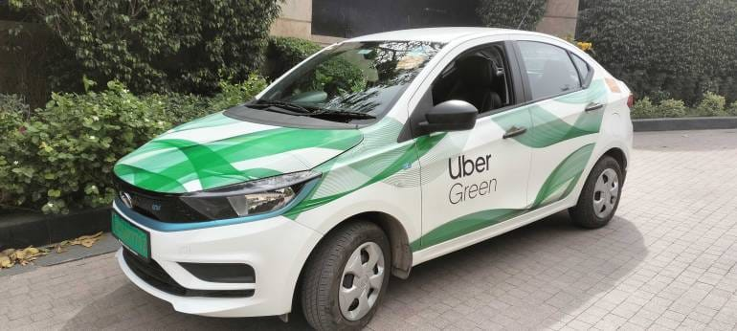

**Conclusion:**

Uber exemplifies the transformative power of technology and innovation. It has transformed the transportation industry and has since expanded into other industries such as food delivery and freight logistics. At the same time, it has created more flexible employment opportunities and made transportation more accessible and user-friendly for consumers worldwide.

Yet, Uber has also encountered significant challenges, ranging from regulatory hurdles, safety concerns, to driver compensation issues. The company's commitment to sustainability and addressing its environmental footprint through initiatives like Uber Green shows its adaptability and responsibility towards global concerns.

To summarize, Uber exemplifies how forward-thinking business models can disrupt traditional industries, provide enormous benefits to consumers, and yet must constantly adapt and evolve to meet the challenges posed by their impact on society and the environment.

**Top Features of Uber:**

**1. Easy User Interface:** Uber's app is designed to be user-friendly, making it simple for people of all age groups to book a ride.

**2. Real-Time Tracking:** Customers can track their ride in real-time on the map and see the estimated arrival time.

**3. Fare Estimation:** Before confirming a ride, users can get an estimate of the fare, allowing them to plan their travel expenses. Also they have multiple payment options.

**4. Driver Rating Systems:** After each trip, passengers can rate their drivers, providing feedback on their ride experience. This ensures high standard services and maintains driver accountability.

**5. Schedule a Ride:** Customers can schedule a ride in advance, securing their travel plans for crucial trips like airline travel. Also, they can book their ride through the app very easily without wandering around on road to look for a cab.

**6. Variety of Service Options:** Uber offers a range of service options to cater to different customer needs, including budget rides which include bikes, auto etc, luxury rides which comes under Uber Black, and rides for larger groups includes sedans and SUV vehicles.

**7. Share My Trip:** For additional safety, Uber allows passengers to share their ride details, including real-time location, with trusted contacts.

**8. Multiple Drop-off Points:** Passengers can add multiple drop-off points on their route if they are sharing the ride with others or have multiple destinations. These features, combined with continuous updates and improvements, have played a significant role in Uber's success as a leading ride-sharing platform globally.

**Schema Description:**

Uber's schema includes several entities that represent various aspects of the platform. These entities include Rider, Driver, Trips, Payments, Requests, Cancel Request, Vehicle, and others. Each entity has attributes that describe its properties and relationships with other entities.

**Rider Entity:** Riders are the passengers who use Uber services to travel or order food etc.

* **Rider ID (Primary Key):** A unique identifier for each user.
* **First Name:** The rider’s first name
* **Last Name:** The rider’s last name
* **Email:** The rider's email address for account-related communication.
* **Gender:** Male/Female/Others
* **Mobile No:** Cannot be greater than 10 digits
* **Password:** Min 8 characters and Max 20 characters
* **Rating:** Range between 0-5, where default is 5

**Driver Entity:** Driver are the ones who drive the customer around and deliver the packages to the customers. For example, drivers and delivery persons.

* **Driver ID (Primary Key):** A unique identifier for each user.
* **First Name:** The rider’s first name
* **Last Name:** The rider’s last name
* **Email:** The rider's email address for account-related communication.
* **Gender:** Male/Female/Others
* **Mobile No:** Cannot be greater than 10 digits
* **Password:** Min 8 characters and Max 20 characters
* **Rating:** Range between 0-5, where default is 5
* **Driver’s License (Primary Key):** A valid driver’s license issued by local government.

**Vehicle Entity:** This contains all the details related to vehicle like Vehicle Registration, Vehicle Insurance, VIN number, Make, Model, Year etc.

* **Car VIN Number (Primary key):** The VIN number of the car which is unique to all vehicles
* **Model:** Model of the vehicle
* **Make:** Company of the vehicle
* **Year:** The year of manufacture of the vehicle. Also, no car older than 2013 for Uber Rides and for Uber Eats it should be no older than 2010
* **Capacity:** The number of passengers it can carry. Min 2 and Max 7
* **Colour:** Colour of the vehicle
* **Vehicle Registration:** Vehicle registration details covering all necessary details
* **Vehicle Insurance:** Vehicle Insurance details covering all necessary details
* **Vehicle Type:** Is it a bike, auto, car. If car is it a hatch back, sedan or SUV
* **Fuel:** Consumes diesel, petrol or electric

**Request Entity:** Here the rider can request a ride by providing pick and drop locations and other required details.

* **Request ID (Primary Key):** A unique trip id created as soon a ride is requested.
* **Driver ID (Foreign Key):** It is the ID of the driver who is assigned.
* **Rider ID (Foreign Key):** It is the ID of the rider who requested the ride.
* **Surge:** It is the peak business hours where the demand is very high for cabs or deliveries.
* **Date and Time:** Date and time of the booking or a delivery.
* **Ride Type:** Uber pool, Uber go, Uber premier, Uber auto, Uber moto
* **Pickup Location:** The location from where the rider needs to be picked up.
* **Drop Location:** The location where the rider needs to be dropped.
* **Estimated Fare:** The estimated fare which is displayed to rider before booking a ride.
* **No. of Seats:** Ranging from 1 to 7

**Trip Entity:** Once the requested is accepted by the driver trip begins.

* **Trip ID (Primary Key):** A unique trip id created once the trip once it is accepted by driver
* **Request ID (Foreign Key):** A unique trip id created as soon a ride is requested.
* **Driver ID (Foreign Key):** It is the ID of the driver who is assigned.
* **Rider ID (Foreign Key):** It is the ID of the rider who requested the ride.
* **Start time:** Time when the trip begins
* **Duration:** Total duration of the trip right from the begin till the end.
* **Fare:** Amount to be paid for the trip
* **Tip:** Tip to the driver (Optional)
* **Driver Rating:** Ratings given by driver to rider at the end of the trip
* **Rider Rating:** Ratings given by rider to driver at the end of the trip
* **Feedback:** To be filled by rider if they want to give any feedback after the trip ends.

**Payment Methods Entity:** After the trip ends rider have varieties of options to pay for the ride.

* **Gift Card** 
  + **Expiry date:** Expiry date of the gift card.
  + **Card Number (Primary Key):** Unique number assigned for gift card
* **Pay Pal**
  + **Pay Pal ID (Primary Key):**
* **Card**
  + **Card Number:** Number of the card
  + **Expiry Date:** Validity of the card
  + **Name:** Card holder name on card
  + **Type of Card:** Debit/Credit
* **Uber Credits:** Uber wallet

**Cancel Request Entity:** When a rider or a driver cancel the trip then the cancel request ID is created.

* **Request ID (Foreign Key/Primary Key):** A unique trip id created as soon a ride is requested.
* **Rider ID (Foreign Key/Primary Key):** It is the ID of the rider who requested the ride.
* **Driver ID (Foreign Key/Primary Key):** It is the ID of the driver who is assigned.
* **Penalty:** Fine given to the rider or a driver for cancellation
* **Cancel Time:** When the trip is cancelled
* **Cancelled by:** Who cancelled the ride.
* **Reason:** Reason for the cancellation

**Relationships are:**

**1. Rider** can **request** multiple **trips** provided he/she can request for other trip after completion of the current trip. Also, he /she has multiple **vehicle types** to opt for based on requirement.

**2. Driver** can do multiple **trips** provided he/she has to complete the existing trip.

**3.** Once the **trip** is accepted by the driver **vehicle details** and other **request entity** details are displayed to the **rider** in the app.

**4.** Once **trip** is completed **rider** can pay the driver with multiple **payment options**.

**5. Rider** or **driver** can both **cancel** the ride after it is **requested** by the rider.

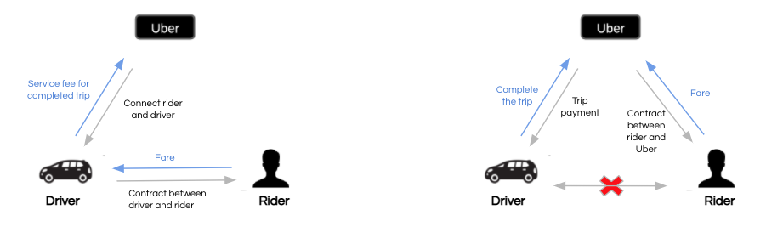

**ER Diagram:**

Let's draw an ER diagram that depicts the relationships and attributes of the entities in the Uber schema in great detail. This ER diagram will be used as a visual representation to shed light on the key components of Uber's data model.

Entities

Sub Entities

Possibilities

Primary Key

­­­­­­ Features

Sub Features

`

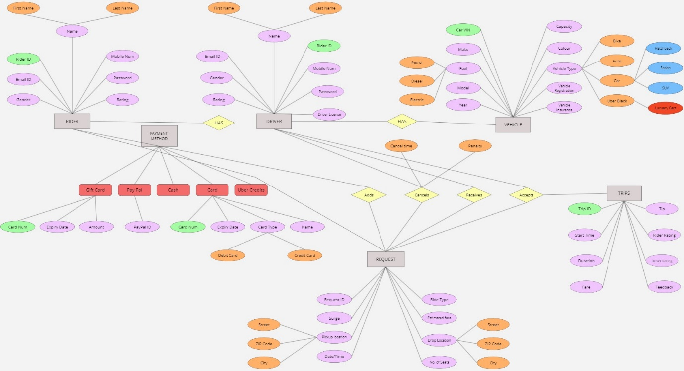

**Conclusion**

In this case study, we delved into the design of Uber's schema and Entity-Relationship diagram. Uber has revolutionised the way people book their cab, order their food, book a load for freight services. Uber's system is a well-structured model that efficiently manages interactions between riders, drivers, and their vehicles. It manages service requests and trips, offers multiple payment options, and has cancellation mechanisms in place. This strong foundation is critical to Uber's ability to provide dependable and convenient transportation services to millions of users worldwide.